PRUEBA SABER 11

PARTE 3

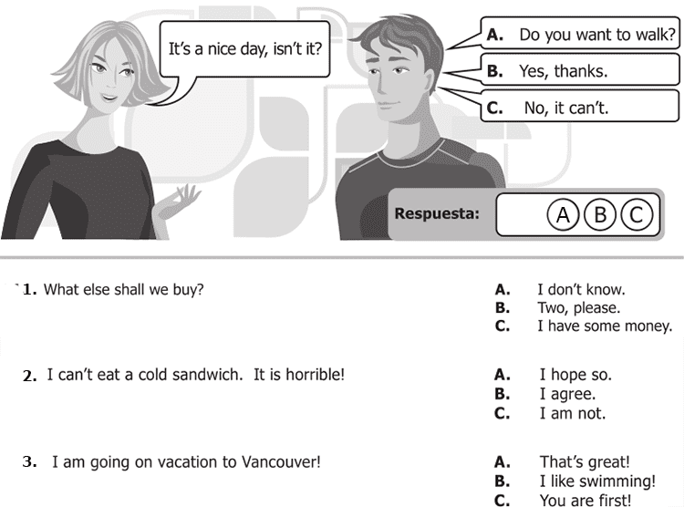

**4 .** It rained a lot last night! A. Did you accept?

B. Did you understand?

C. Did you sleep?

5. Grandma, shall I hold those bags for you? A. I'm not afraid!

B. What's the matter?

C. That's fine.

6. How much is that umbrella? A. Anything else?

B. 50 dollars.

C. Cash only!

7. Can I use your printer? A. Just a minute

B. Do it this way

C. Think about it

8. Who´s the girl? A. She´s my sister

B. Yes, she is

C. That´s ok

9. Do you know Peter? A. Which?

B. who?

C. What?

10. Can you pass me the salt? A. Here you are

B. I like it

C. It´s all right

**Continue next page**

